Assignment 3
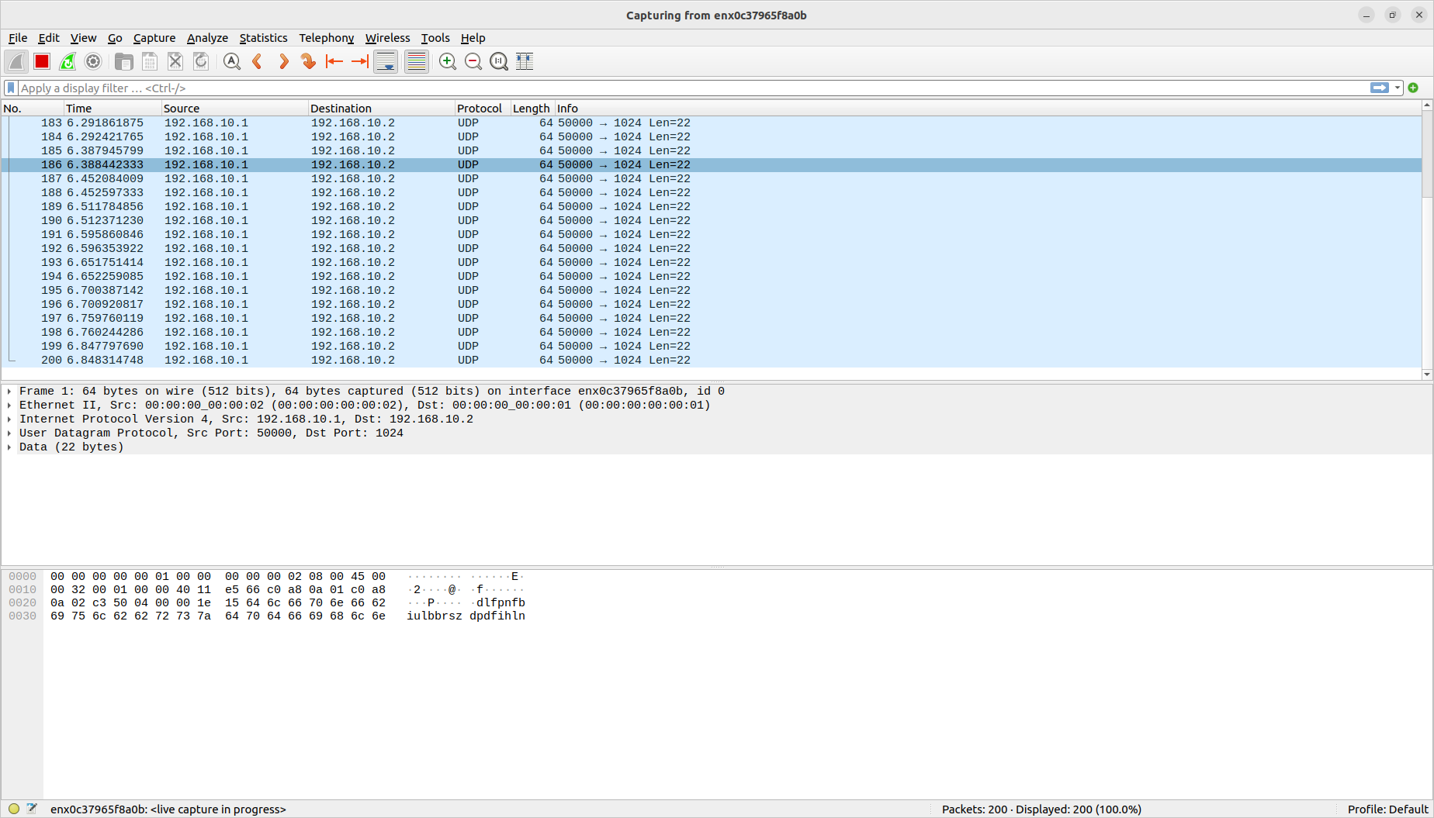
before package drops – 200 packets

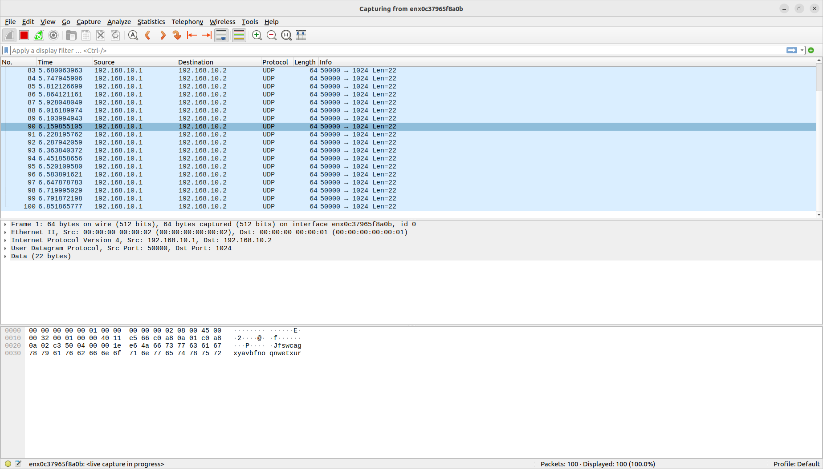
after package drops – only 100

This is achieved by adding the following table entry:
table_add MyIngress.src_mac_drop MyIngress.drop 00:00:00:00:00:02 =>

